(26) Gulko,B (2520) - Popovic,P (2540) E20; Clichy, 1986
Boris: After my immigration in 1986, my first three international tournaments I played in France and won all three (after this for some reason I didn’t play any international tournaments in France). This game was from the second of my French tournaments.
1 c4 Nf6 2 Nc3 e6 3 Nf3 Bb4 4 g3 0–0 5 Bg2 d5 6 d4 dxc4 7 0–0 Nc6 8 a3
Boris: In my game with Lputien, which we previously discussed, I played 8 Re1. Now I wanted to play something different.
8...Be7 9 e4 Na5 10 Bf4 c6?!
Boris: This move is a serious inaccuracy. Much stronger was 10...Nb3! 11 Rb1 c6 12 h3 b5 and if white moves his queen to e2 the d4 pawn will hang
11 Qe2 b5 12 Rad1 Bb7 13 Rfe1© a6 14 Ne5 Re8
Boris: Black has to keep an eye on the d5 square. If 14...Nd7?! then very strong would be 15 d5!±; Instead of the prophylactic move played in the game in which black places the rook directly opposite the white queen and additionally protects the e7 bishop white could have also played 14...Nb3!? or; 14...Qb6!? 15 g4 Rad8 16 g5 Nd7÷
15 Bh3! Bf8
Black cannot move the queen to her most natural square 15...Qb6? Because white has a combination.
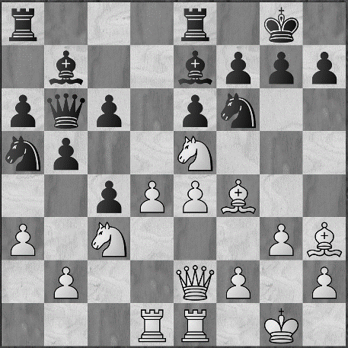
Can you find it? (difficulty level 3)
Joel: First I was thinking about 16 Nf3 and 16 Ng4 with the idea of trading off black’s important kingside defender and then playing e4-e5 but that is not in the spirit of my new aggressive approach. Instead, I like 16 Nxf7 Kxf7 17 e5 followed by Qe2-h5+ and Bxe6 with a strong attack.
Boris: Very nice! You solved this problem and it is very nice that you noticed that the queen abandoned the kingside and that you took the moment to attack. 16 Nxf7!! Kxf7 17 e5 Nd5 (17...c5 18 exf6 Bxf6 19 dxc5+-) 18 Qh5+ Kg8 19 Bxe6+ Kh8 20 Bf5+- and black is defenceless
16 Qf3 Qe7
Boris: An awkward move but the f7 square needs extra protection. In the case of 16...Qb6 17 g4!± with the threat of 18 g5 and it is not easy for black to protect the f7 square(now bad for white would be 17 Nxf7? because after 17...Kxf7 18 e5 black has 18...c5µ)
17 g4! Rad8?
Boris: Black has to rush to reduce the tension with 17...Nd7™ 18 Nxd7 Qxd7 19 g5 Rad8 20 Qg3 Nb3 21 d5 with a sharp struggle.
Joel: I don’t understand why he has to rush to reduce the tension and what 17...Nd7 accomplished?
Boris: He can exchange white’s knight on e5 and exchange pieces too, which is favourable for the defending side.
18 g5 Nd7 19 Qg3! Nb3
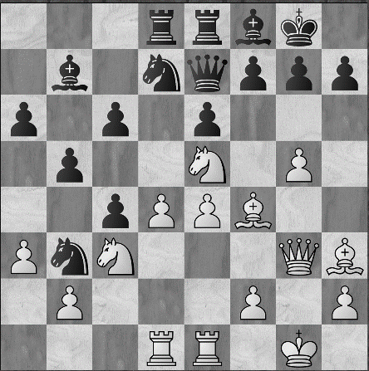
How can white maintain the pressure? (difficulty level 3)
Joel: Based on what you just said about the defending side wanting to exchange pieces, I would play 20 Ng4 keeping the pieces on the board. White seems to have a lot of threats still in the air.
Boris: You’re right that for white it is important to keep pieces on the board and avoid exchanges. Now it becomes clear why it was important to not miss the opportunity to exchange pieces on move 17 but the g4 square is not the best for white because in the complications it is important for white to keep the e1 rook extra protected so the correct move is 20 Nf3.
Boris: Here is too late for black to exchange knights because after 19...Nxe5 20 Bxe5± it is not easy to defend against both 21 Bc7 and 21 Bf6 threats
20 Nf3!± b4?!
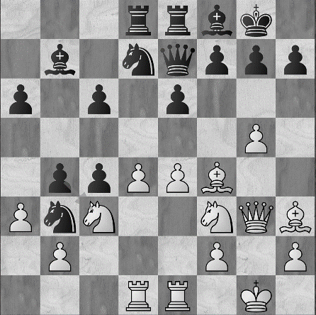
What does white have to do? (difficulty level 5)
Joel: I am looking at 21 Nd5 but it seem to work tactically. I’d like to take advantage of the queen having so few squares available to her.
Boris: It loses a piece after 21...cxd5 but it is nice that you see he drawback of black’s claustrophobic situation. How can you use it? Obviously, if 21 axb4 and Qxb4 you will relieve black of his claustrophobia.
Joel: I thought 21 Bc7 was interesting but after 21...bxc3 22 e5 Rc8 the queen has the d8 square.
Boris: Right, any other ideas?
Joel: No, I guess that’s why it is level 5.
Boris: It is strange that you didn’t see the most natural move 21 d5 with the threat of 22 d6 winning the queen. Now you see why it is important to have the knight on f3, after the exchange on d5, black cannot simply take on e1.
21 d5!! cxd5
Boris: The attempt to close the position with 21...e5 would be refuted by 22 d6! exf4 23 dxe7 (also good for white was 23 Qxf4!? Qe5™ 24 Nxe5 Nxe5 25 axb4±) 23...fxg3 24 exd8Q gxf2+ 25 Kxf2 Rxd8 26 axb4+- and white has to win
22 exd5 Nb6 23 d6 Qd7 24 axb4 Qc8 (Not better for black was 24...Qc6 25 Ne4 threatening Ne5)
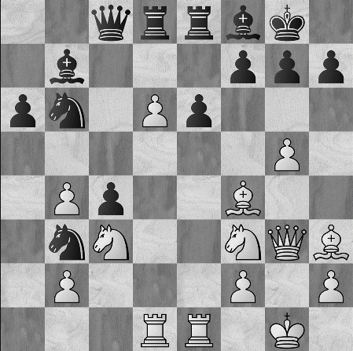
What would do here? (difficulty level 4)
Joel: I don’t see anything!
Boris: But you have a hierarchy to guide you.
Joel: That’s true. Can I mate the king? Well, I have a preponderance of force in the vicinity and there are important defensive resources that are unavailable to the king.
Boris: Good, so how can you attack the king?
Joel: 25 g6
Boris: Correct!
Joel: Are you kidding? That move doesn’t even make sense.
Boris: We saw this idea before in the annotation to move 20. The key idea is to free the g5 square for the knight.
25 g6!+- f6
Boris: In the case of 25...hxg6 26 Ng5 Nd7 27 Qh4 Nf6 white had to see 28 Bg4! and black is defenceless against the threat of (much worse would have been 28 Be5? because of 28...Nh5)
26 gxh7+ Kxh7 27 Ne4 Qd7
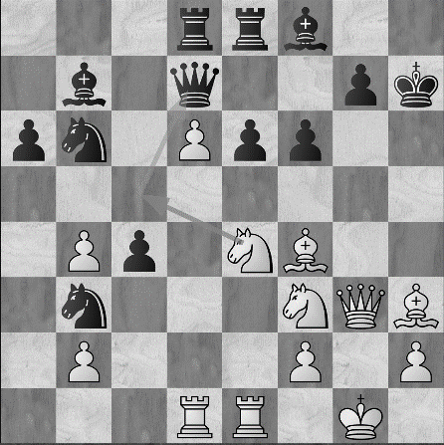
How to continue the attack? (difficulty level 2)
Joel: I’m looking at 28 Neg5+ fxg5 29 Nxg5+ Kg8 30 Rxe6 with a strong attack.
Boris: When you are attacking you have to create threats. 30 Rxe6 does not create threats and black can play 30 Qc6 which does create threats in return. What you missed was 30 Qh4 threatening mate but you had the right idea.
28 Neg5+! fxg5 29 Nxg5+ Kg8 30 Qh4 g6 31 Be5 Bg7 32 Bxe6+ Rxe6 33 Qh7+
Boris: In this game white succeeds in breaking through black’s solid position, The real drawback of black’s knight on b3, which occupied a weak square in white’s camp but did not coordinate with black’s other pieces and did not participate in the game. Chess players have a reflex to occupy weak squares with their knights but using the outside position of this knight on b3 I was able to win two more nice games (one against Gelfand that we annotated in our first book and the other against Lputian annotated in this one).
1–0

